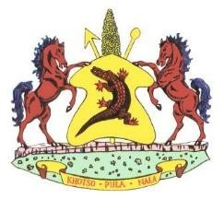
Lesotho permit number…………………………………
VETERINARY HEALTH ATTESTATION FOR FISH
I……………………………………………………………………………………………………………. the undersigned veterinary/official authorized by the Director of Veterinary Services in South Africa attest the following:
- The fish originate from a zone, which has been recognized to be free from epizootic hematopoietic necrosis, infectious pancreatic necrosis, Oncorhynchus masou virus disease, Bacterial kidney disease and viral hemorrhagic septicemia;
- The fish must not in any way be handled so as to allow the transmission of any infectious disease;
- The fish must be transported in containers, which are constructed in such a way so as to prevent the contamination of fish by disease causing agents and equipment with a thermograph;
- The fish must be loaded and sealed by authorized official and the seal number must be indicated on the International veterinary certificate;

Seal No………………………………………………………………………………….

Vehicle No…………………………………………………………………………….

- The exporter/importer has been informed to undertake to inform the government veterinary officials nearest to the point of destination, so that she/he could unseal and check the consignment before it is disposed of in any way.
- The permit is valid for 30 days from date of issue and is for one consignment only.

Signed at……………………………………………………………………… On date………………………………………………………………………
______________________________________________
Authorized Veterinary /Official
Name in print…………………………………………………………………..
Designated Rank……………………………………………………………….
Address…………………………………………………………………………….. Official Stamp

